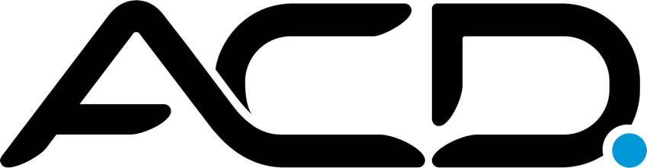

ACD Terms of Service ("Terms")
Policy Version v1.0

Revision History
Version | Date | Author | Description of Change
1.0 | 8/4/2021 | Louise Watson, Production Manager | Terms Created

Please read these Terms of Service ("Terms", "Terms of Service") carefully before using acddirect.com, callswithoutwalls.com, acdagents.com and the SimpleScript, PledgeCart, PODS, and Mobile Canvasser applications (the "Service") operated by ACD Direct, ACD Connect, and eCallogy (“ACD”,"us", "we", or "our").

Your access to and use of the Service is conditioned on your acceptance of and compliance with these Terms. These Terms apply to all visitors, users and others who access or use the Service.

By accessing or using the Service you agree to be bound by these Terms. If you disagree with any part of the terms then you may not access the Service.

Termination

We may terminate or suspend access to our Service immediately, without prior notice or liability, for any reason whatsoever, including without limitation if you breach the Terms.

All provisions of the Terms which by their nature should survive termination shall survive termination, including, without limitation, ownership provisions, warranty disclaimers, indemnity and limitations of liability.

Content

Our Services allow you to post, link, store, share and otherwise make available certain information, text, graphics, videos, or other material ("Content"). The usage rights of this content by ACD, its customers, and third parties is explicitly detailed in Customer contracts and ACD’s Customer Data and Security Responsibilities Policy, which can be found here: https://acddirect.com/policies/.

Links To Other Web Sites

Our Service may contain links to third-party web sites or services that are not owned or controlled by ACD.

ACD has no control over, and assumes no responsibility for, the content, privacy policies, or practices of any third party web sites or services. You further acknowledge and agree that ACD shall not be responsible or liable, directly or indirectly, for any damage or loss caused or alleged to be caused by or in connection with use of or reliance on any such content, goods or services available on or through any such web sites or services.

Changes

We reserve the right, at our sole discretion, to modify or replace these Terms at any time. If a revision is material we will try to provide at least 14 days' notice prior to any new terms taking effect. What constitutes a material change will be determined at our sole discretion.

Contact Us

If you have any questions about these Terms, please contact us at

240 N. East Promontory, Ste 200
Farmington, UT 84025
connect@acddirect.com
(888) 320-0033

